Mongodb Server advanced 8

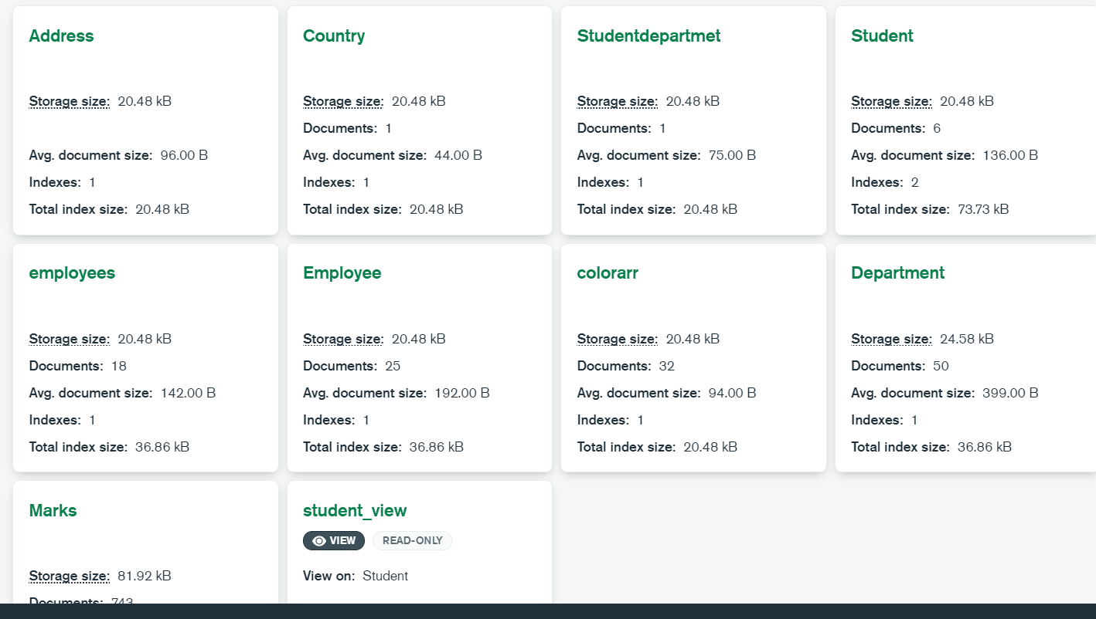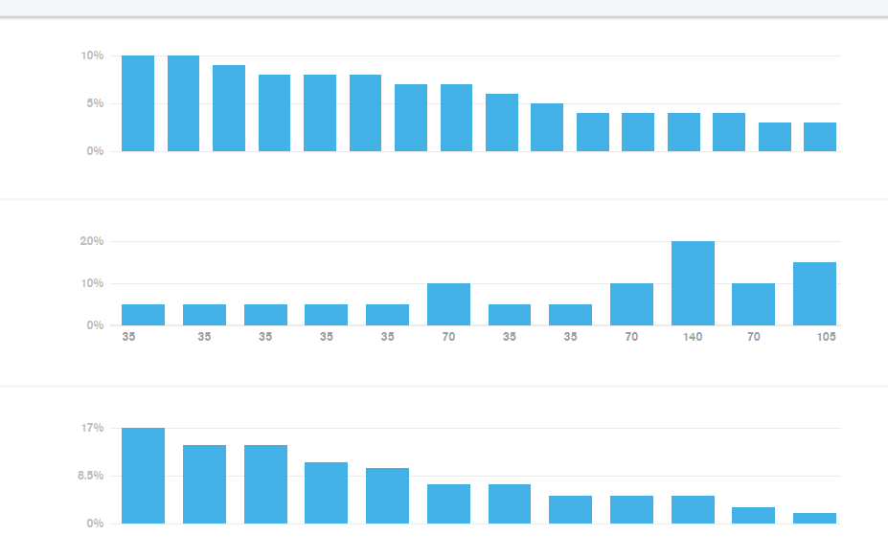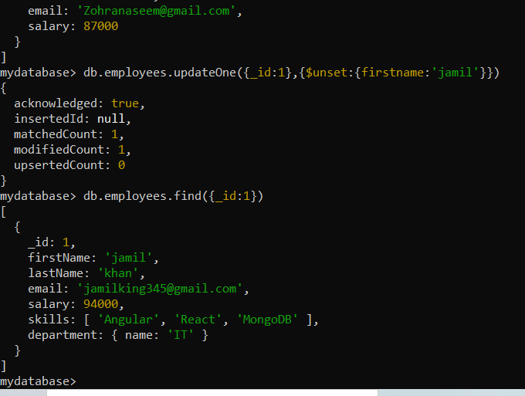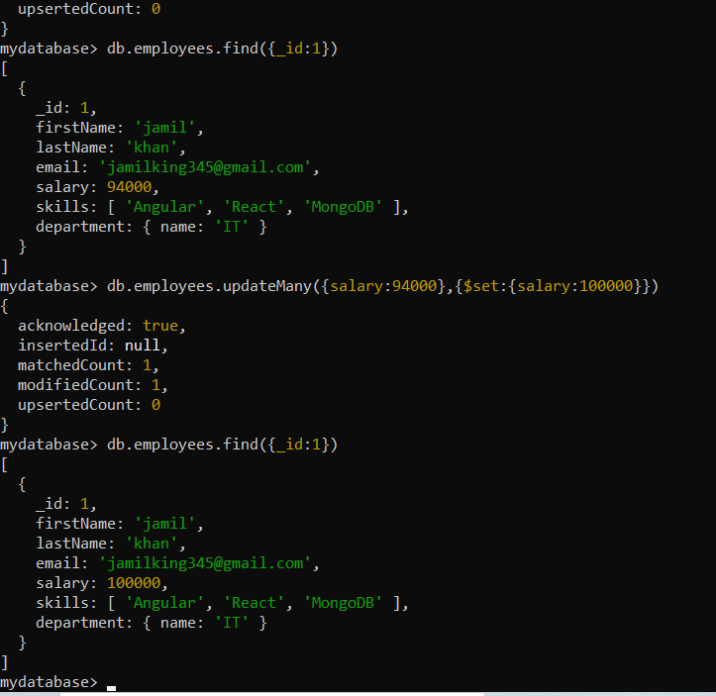

**Codes:(Engr Ajman ullah khan ASE(Data Analyst):**

db.employees.find().sort({"department.name":1})

[

{cknowledged: true,

_id: 4,ds: {

firstName: 'Steve',c2bf0ac0ff7a169fad1f"),

lastName: 'J',"635cc2bf0ac0ff7a169fad20"),

email: 'steve.j@abc.com',c0ff7a169fad21"),

salary: 7000d("635cc2bf0ac0ff7a169fad22"),

},'4': ObjectId("635cc2bf0ac0ff7a169fad23"),

{ '5': ObjectId("635cc2bf0ac0ff7a169fad24")

_id: 6,

firstName: 'Amitabh',

lastName: 'B',

email: 'amitabh.b@abc.com',

salary: 7000

},

{

_id: ObjectId("635cbabc1bc43a2866caf655"),

firstName: 'Waqas',

lastName: 'Ahmad',

email: 'waqasahmat234@gmail.com',

salary: 750000

},

{

_id: ObjectId("635cbaf81bc43a2866caf656"),

firstName: 'Zubair Ali',

lastName: 'Hassan',

email: 'ZubairAli675@gmail.com',

salary: 85000

},

{

_id: ObjectId("635cbb8d1bc43a2866caf657"),

firstName: 'Hassan Ali',

lastName: 'Quershi',

email: 'HassanAli875@gmail.com',

salary: 80000

},

{

_id: ObjectId("635cbbd21bc43a2866caf658"),

firstName: 'Ajman ullah ',

lastName: 'Khan',

email: 'ajman41288@gmail.com',

salary: 87000

},

{

_id: ObjectId("635cbbf91bc43a2866caf659"),

firstName: 'Zohra ',

lastName: 'naseem',

email: 'Zohranaseem@gmail.com',

salary: 87000

},

{

_id: ObjectId("635cc2bf0ac0ff7a169fad22"),

firstName: 'Steve',

lastName: 'J',

email: 'steve.j@abc.com',

salary: 7000

},

{

_id: ObjectId("635cc2bf0ac0ff7a169fad24"),

firstName: 'Amitabh',

lastName: 'B',

email: 'amitabh.b@abc.com',

salary: 7000

},

{

_id: 2,

firstName: 'Sachin',

lastName: 'T',

email: 'sachin.t@abc.com',

salary: 8000,

skills: [ 'Accounting', 'Tax' ],

department: { name: 'Finance' }

},

{

_id: 5,

firstName: 'Kapil',

lastName: 'D',

email: 'kapil.d@abc.com',

salary: 4500,

skills: [ 'Accounting', 'Tax' ],

department: { name: 'Finance' }

},

{

_id: ObjectId("635cc2bf0ac0ff7a169fad20"),

firstName: 'Sachin',

lastName: 'T',

email: 'sachin.t@abc.com',

salary: 8000,

skills: [ 'Accounting', 'Tax' ],

department: { name: 'Finance' }

},

{

_id: ObjectId("635cc2bf0ac0ff7a169fad23"),

firstName: 'Kapil',

lastName: 'D',

email: 'kapil.d@abc.com',

salary: 4500,

skills: [ 'Accounting', 'Tax' ],

department: { name: 'Finance' }

},

{

_id: 1,

firstName: 'John',

lastName: 'King',

email: 'john.king@abc.com',

salary: 5000,

skills: [ 'Angular', 'React', 'MongoDB' ],

department: { name: 'IT' }

},

{

_id: ObjectId("635cc2380ac0ff7a169fad1a"),

firstName: 'John',

lastName: 'King',

email: 'john.king@abc.com',

salary: 5000,

skills: [ 'Angular', 'React', 'MongoDB' ],

department: { name: 'IT' }

},

{

_id: ObjectId("635cc2bf0ac0ff7a169fad1f"),

firstName: 'John',

lastName: 'King',

email: 'john.king@abc.com',

salary: 5000,

skills: [ 'Angular', 'React', 'MongoDB' ],

department: { name: 'IT' }

},

{

_id: 3,

firstName: 'James',

lastName: 'Bond',

email: 'jamesb@abc.com',

salary: 7500,

skills: [ 'Sales', 'Marketing' ],

department: { name: 'Marketing' }

},

{

_id: ObjectId("635cc2bf0ac0ff7a169fad21"),

firstName: 'James',

lastName: 'Bond',

email: 'jamesb@abc.com',

salary: 7500,

skills: [ 'Sales', 'Marketing' ],

department: { name: 'Marketing' }

}

]

mydatabase> db.employees.updateOne({_id:1},{$set:{firstname:"jamil"}})

{

acknowledged: true,

insertedId: null,

matchedCount: 1,

modifiedCount: 1,

upsertedCount: 0

}

mydatabase> db.employees.updateOne({_id:1},{$set:{firstName:"jamil"}})

{

acknowledged: true,

insertedId: null,

matchedCount: 1,

modifiedCount: 1,

upsertedCount: 0

}

mydatabase> db.employees.find({_id:1})

[

{

_id: 1,

firstName: 'jamil',

lastName: 'King',

email: 'john.king@abc.com',

salary: 5000,

skills: [ 'Angular', 'React', 'MongoDB' ],

department: { name: 'IT' },

firstname: 'jamil'

}

]

mydatabase> db.employees.updateOne({firstName:"jamil"},{$set:{email:"jamilking345@gmail.com"}})

{

acknowledged: true,

insertedId: null,

matchedCount: 1,

modifiedCount: 1,

upsertedCount: 0

}

mydatabase> db.employees.find({firstName:"jamil"})

[

{

_id: 1,

firstName: 'jamil',

lastName: 'King',

email: 'jamilking345@gmail.com',

salary: 5000,

skills: [ 'Angular', 'React', 'MongoDB' ],

department: { name: 'IT' },

firstname: 'jamil'

}

]

mydatabase> db.employees.updateOne({firstName:"jamil"},{$set:{lastName:"khan",email:"jamilking345@gmail.com",salary:89000}})

{

acknowledged: true,

insertedId: null,

matchedCount: 1,

modifiedCount: 1,

upsertedCount: 0

}

mydatabase> db.employees.find({firstName:"jamil"})

[

{

_id: 1,

firstName: 'jamil',

lastName: 'khan',

email: 'jamilking345@gmail.com',

salary: 89000,

skills: [ 'Angular', 'React', 'MongoDB' ],

department: { name: 'IT' },

firstname: 'jamil'

}

]

mydatabase> db.employees.updateOne({salary},{$inc:{salary:5000}})

ReferenceError: salary is not defined

mydatabase> db.employees.updateOne({salary:{$gte:5000}},{$inc:{salary:5000}})

{

acknowledged: true,

insertedId: null,

matchedCount: 1,

modifiedCount: 1,

upsertedCount: 0

}

mydatabase> db.employees.find({salary:{$gte:10000}})

[

{

_id: 1,

firstName: 'jamil',

lastName: 'khan',

email: 'jamilking345@gmail.com',

salary: 94000,

skills: [ 'Angular', 'React', 'MongoDB' ],

department: { name: 'IT' },

firstname: 'jamil'

},

{

_id: ObjectId("635cbabc1bc43a2866caf655"),

firstName: 'Waqas',

lastName: 'Ahmad',

email: 'waqasahmat234@gmail.com',

salary: 750000

},

{

_id: ObjectId("635cbaf81bc43a2866caf656"),

firstName: 'Zubair Ali',

lastName: 'Hassan',

email: 'ZubairAli675@gmail.com',

salary: 85000

},

{

_id: ObjectId("635cbb8d1bc43a2866caf657"),

firstName: 'Hassan Ali',

lastName: 'Quershi',

email: 'HassanAli875@gmail.com',

salary: 80000

},

{

_id: ObjectId("635cbbd21bc43a2866caf658"),

firstName: 'Ajman ullah ',

lastName: 'Khan',

email: 'ajman41288@gmail.com',

salary: 87000

},

{

_id: ObjectId("635cbbf91bc43a2866caf659"),

firstName: 'Zohra ',

lastName: 'naseem',

email: 'Zohranaseem@gmail.com',

salary: 87000

}

]

mydatabase> db.employees.updateOne({_id:1},{$unset:{firstname:'jamil'}})

{

acknowledged: true,

insertedId: null,

matchedCount: 1,

modifiedCount: 1,

upsertedCount: 0

}

mydatabase> db.employees.find({_id:1})

[

{

_id: 1,

firstName: 'jamil',

lastName: 'khan',

email: 'jamilking345@gmail.com',

salary: 94000,

skills: [ 'Angular', 'React', 'MongoDB' ],

department: { name: 'IT' }

}

]

mydatabase> db.employees.updateMany({salary:94000},{$set:{salary:100000}})

{

acknowledged: true,

insertedId: null,

matchedCount: 1,

modifiedCount: 1,

upsertedCount: 0

}

mydatabase> db.employees.find({_id:1})

[

{

_id: 1,

firstName: 'jamil',

lastName: 'khan',

email: 'jamilking345@gmail.com',

salary: 100000,

skills: [ 'Angular', 'React', 'MongoDB' ],

department: { name: 'IT' }

}

]

mydatabase> db.employees.updateMany({},{$set:{Location:"Pakistan"}})

{

acknowledged: true,

insertedId: null,

matchedCount: 18,

modifiedCount: 18,

upsertedCount: 0

}

mydatabase> db.employees.find({Location:"pakistan"})

mydatabase> db.employees.find({Location:"Pakistan"})

[

{

_id: 1,

firstName: 'jamil',

lastName: 'khan',

email: 'jamilking345@gmail.com',

salary: 100000,

skills: [ 'Angular', 'React', 'MongoDB' ],

department: { name: 'IT' },

Location: 'Pakistan'

},

{

_id: 2,

firstName: 'Sachin',

lastName: 'T',

email: 'sachin.t@abc.com',

salary: 8000,

skills: [ 'Accounting', 'Tax' ],

department: { name: 'Finance' },

Location: 'Pakistan'

},

{

_id: 3,

firstName: 'James',

lastName: 'Bond',

email: 'jamesb@abc.com',

salary: 7500,

skills: [ 'Sales', 'Marketing' ],

department: { name: 'Marketing' },

Location: 'Pakistan'

},

{

_id: 4,

firstName: 'Steve',

lastName: 'J',

email: 'steve.j@abc.com',

salary: 7000,

Location: 'Pakistan'

},

{

_id: 5,

firstName: 'Kapil',

lastName: 'D',

email: 'kapil.d@abc.com',

salary: 4500,

skills: [ 'Accounting', 'Tax' ],

department: { name: 'Finance' },

Location: 'Pakistan'

},

{

_id: 6,

firstName: 'Amitabh',

lastName: 'B',

email: 'amitabh.b@abc.com',

salary: 7000,

Location: 'Pakistan'

},

{

_id: ObjectId("635cbabc1bc43a2866caf655"),

firstName: 'Waqas',

lastName: 'Ahmad',

email: 'waqasahmat234@gmail.com',

salary: 750000,

Location: 'Pakistan'

},

{

_id: ObjectId("635cbaf81bc43a2866caf656"),

firstName: 'Zubair Ali',

lastName: 'Hassan',

email: 'ZubairAli675@gmail.com',

salary: 85000,

Location: 'Pakistan'

},

{

_id: ObjectId("635cbb8d1bc43a2866caf657"),

firstName: 'Hassan Ali',

lastName: 'Quershi',

email: 'HassanAli875@gmail.com',

salary: 80000,

Location: 'Pakistan'

},

{

_id: ObjectId("635cbbd21bc43a2866caf658"),

firstName: 'Ajman ullah ',

lastName: 'Khan',

email: 'ajman41288@gmail.com',

salary: 87000,

Location: 'Pakistan'

},

{

_id: ObjectId("635cbbf91bc43a2866caf659"),

firstName: 'Zohra ',

lastName: 'naseem',

email: 'Zohranaseem@gmail.com',

salary: 87000,

Location: 'Pakistan'

},

{

_id: ObjectId("635cc2380ac0ff7a169fad1a"),

firstName: 'John',

lastName: 'King',

email: 'john.king@abc.com',

salary: 5000,

skills: [ 'Angular', 'React', 'MongoDB' ],

department: { name: 'IT' },

Location: 'Pakistan'

},

{

_id: ObjectId("635cc2bf0ac0ff7a169fad1f"),

firstName: 'John',

lastName: 'King',

email: 'john.king@abc.com',

salary: 5000,

skills: [ 'Angular', 'React', 'MongoDB' ],

department: { name: 'IT' },

Location: 'Pakistan'

},

{

_id: ObjectId("635cc2bf0ac0ff7a169fad20"),

firstName: 'Sachin',

lastName: 'T',

email: 'sachin.t@abc.com',

salary: 8000,

skills: [ 'Accounting', 'Tax' ],

department: { name: 'Finance' },

Location: 'Pakistan'

},

{

_id: ObjectId("635cc2bf0ac0ff7a169fad21"),

firstName: 'James',

lastName: 'Bond',

email: 'jamesb@abc.com',

salary: 7500,

skills: [ 'Sales', 'Marketing' ],

department: { name: 'Marketing' },

Location: 'Pakistan'

},

{

_id: ObjectId("635cc2bf0ac0ff7a169fad22"),

firstName: 'Steve',

lastName: 'J',

email: 'steve.j@abc.com',

salary: 7000,

Location: 'Pakistan'

},

{

_id: ObjectId("635cc2bf0ac0ff7a169fad23"),

firstName: 'Kapil',

lastName: 'D',

email: 'kapil.d@abc.com',

salary: 4500,

skills: [ 'Accounting', 'Tax' ],

department: { name: 'Finance' },

Location: 'Pakistan'

},

{

_id: ObjectId("635cc2bf0ac0ff7a169fad24"),

firstName: 'Amitabh',

lastName: 'B',

email: 'amitabh.b@abc.com',

salary: 7000,

Location: 'Pakistan'

}

]

mydatabase> db.employees.updateMany({Location:"Pakistan"},{$set:{firstName:"Haris",lastName:"Khan",salary:85000}})

{

acknowledged: true,

insertedId: null,

matchedCount: 18,

modifiedCount: 18,

upsertedCount: 0

}

mydatabase> db.employees.find({Location:"Pakistan"})

[

{

_id: 1,

firstName: 'Haris',

lastName: 'Khan',

email: 'jamilking345@gmail.com',

salary: 85000,

skills: [ 'Angular', 'React', 'MongoDB' ],

department: { name: 'IT' },

Location: 'Pakistan'

},

{

_id: 2,

firstName: 'Haris',

lastName: 'Khan',

email: 'sachin.t@abc.com',

salary: 85000,

skills: [ 'Accounting', 'Tax' ],

department: { name: 'Finance' },

Location: 'Pakistan'

},

{

_id: 3,

firstName: 'Haris',

lastName: 'Khan',

email: 'jamesb@abc.com',

salary: 85000,

skills: [ 'Sales', 'Marketing' ],

department: { name: 'Marketing' },

Location: 'Pakistan'

},

{

_id: 4,

firstName: 'Haris',

lastName: 'Khan',

email: 'steve.j@abc.com',

salary: 85000,

Location: 'Pakistan'

},

{

_id: 5,

firstName: 'Haris',

lastName: 'Khan',

email: 'kapil.d@abc.com',

salary: 85000,

skills: [ 'Accounting', 'Tax' ],

department: { name: 'Finance' },

Location: 'Pakistan'

},

{

_id: 6,

firstName: 'Haris',

lastName: 'Khan',

email: 'amitabh.b@abc.com',

salary: 85000,

Location: 'Pakistan'

},

{

_id: ObjectId("635cbabc1bc43a2866caf655"),

firstName: 'Haris',

lastName: 'Khan',

email: 'waqasahmat234@gmail.com',

salary: 85000,

Location: 'Pakistan'

},

{

_id: ObjectId("635cbaf81bc43a2866caf656"),

firstName: 'Haris',

lastName: 'Khan',

email: 'ZubairAli675@gmail.com',

salary: 85000,

Location: 'Pakistan'

},

{

_id: ObjectId("635cbb8d1bc43a2866caf657"),

firstName: 'Haris',

lastName: 'Khan',

email: 'HassanAli875@gmail.com',

salary: 85000,

Location: 'Pakistan'

},

{

_id: ObjectId("635cbbd21bc43a2866caf658"),

firstName: 'Haris',

lastName: 'Khan',

email: 'ajman41288@gmail.com',

salary: 85000,

Location: 'Pakistan'

},

{

_id: ObjectId("635cbbf91bc43a2866caf659"),

firstName: 'Haris',

lastName: 'Khan',

email: 'Zohranaseem@gmail.com',

salary: 85000,

Location: 'Pakistan'

},

{

_id: ObjectId("635cc2380ac0ff7a169fad1a"),

firstName: 'Haris',

lastName: 'Khan',

email: 'john.king@abc.com',

salary: 85000,

skills: [ 'Angular', 'React', 'MongoDB' ],

department: { name: 'IT' },

Location: 'Pakistan'

},

{

_id: ObjectId("635cc2bf0ac0ff7a169fad1f"),

firstName: 'Haris',

lastName: 'Khan',

email: 'john.king@abc.com',

salary: 85000,

skills: [ 'Angular', 'React', 'MongoDB' ],

department: { name: 'IT' },

Location: 'Pakistan'

},

{

_id: ObjectId("635cc2bf0ac0ff7a169fad20"),

firstName: 'Haris',

lastName: 'Khan',

email: 'sachin.t@abc.com',

salary: 85000,

skills: [ 'Accounting', 'Tax' ],

department: { name: 'Finance' },

Location: 'Pakistan'

},

{

_id: ObjectId("635cc2bf0ac0ff7a169fad21"),

firstName: 'Haris',

lastName: 'Khan',

email: 'jamesb@abc.com',

salary: 85000,

skills: [ 'Sales', 'Marketing' ],

department: { name: 'Marketing' },

Location: 'Pakistan'

},

{

_id: ObjectId("635cc2bf0ac0ff7a169fad22"),

firstName: 'Haris',

lastName: 'Khan',

email: 'steve.j@abc.com',

salary: 85000,

Location: 'Pakistan'

},

{

_id: ObjectId("635cc2bf0ac0ff7a169fad23"),

firstName: 'Haris',

lastName: 'Khan',

email: 'kapil.d@abc.com',

salary: 85000,

skills: [ 'Accounting', 'Tax' ],

department: { name: 'Finance' },

Location: 'Pakistan'

},

{

_id: ObjectId("635cc2bf0ac0ff7a169fad24"),

firstName: 'Haris',

lastName: 'Khan',

email: 'amitabh.b@abc.com',

salary: 85000,

Location: 'Pakistan'

}

]

mydatabase>

